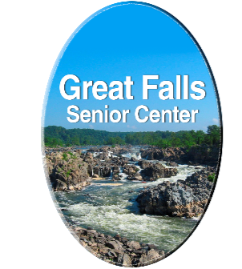
Great Falls Senior Center Sponsors
Thank You For Supporting our 2020-2022 Events

Tribute Assisted Living Ashburn
Great Falls Assisted Living
The Mather Luxury Living for Seniors
Costa Family & Cosmetic Dentistry
Celebrate Great Falls Foundation
John Nugent and Sons
Brightview Senior Living Great Falls
Great Falls Area Ministries
Great Falls Rotary Club
Great Falls Friends and Neighbors
Adams-Green Funeral Home Herndon
Dr. and Mrs. William M. Busey Family

Our Mission: To serve, support and enrich the lives
of older adults in the Great Falls community.
Join Us
Great Falls Senior Center
PO Box 425, Great Fall, VA 22066
www.gfseniors.org

